Footprints

**Winter 2010 ● Quest Specialty Travel News and Notes ● Volume VII, Number 4**

QST World Travel News

**QST Launches New Tours to South Africa**

QST is pleased to announce two new adventure tours to the hottest travel destination in Africa: South Africa. Ron Dawson, vice president of marketing, said of the tours, “Seeing big game in South Africa is the thrill of a lifetime. These two new itineraries combine first-class adventure with incomparable cultural access to local inhabitants. They epitomize QST’s mission to help people better understand the world and its people.”

The 10-day **South Africa Safari** is an adventurer’s dream come true. The tour commences in Johannesburg and begins with an overnight visit to a multicultural village where clients stay as guests of African families. After immersion in the culture and heritage of the Basotho, Pedi, Xhosa, and Zulu tribes, the tour explores some of the great national parks of the northeast, including the famed Kruger, with a series of exciting game-drives in open, all-terrain, solar-powered vehicles. Next is a safari in the incomparable Hluhluwe-Umfolozi Game Park, where sightings of rhinos, lions, buffaloes, leopards, elephants, zebras, cheetahs, and giraffes are commonplace. Finally, the tour explores the St. Lucia Wetlands, one of the world’s great eco-tourism destinations.

The second tour, the wonderfully scenic 8-day **Garden of South Africa**,includes coastal panoramas, inland reserves, and artist colonies. The tour begins in Port Elizabeth and travels along the garden route of the south, leading to Cape Town, one of the world's most beautiful cities. Highlights include the town of Knysna, set on a beautiful lagoon system and surrounded by forest, and Tsitsikamma National Park. The last few days of the tour are spent exploring spectacular Cape Town, renowned for the best food and nightlife in South Africa, as well as the Cape of Good Hope.

**QST Scoops World Travel Award**

QST was awarded the prestigious Word Travel Award for Best Eco-Tour Operator at the 18th Annual World Travel Awards, held in August in Turks and Caicos. The award, presented to QST Chief Executive Officer, Jessica Long, was voted on by 167,000 travel professionals worldwide. “It is an honor to be recognized as the leading operator in eco-tourism,” said Long. “We are extremely proud of all we have accomplished and the innovation we bring to the eco-travel industry.”

Quest Specialty Travel: Adventure, Culture, Education

**C:\Documents and Settings\Jen\Local Settings\Temporary Internet Files\Content.IE5\OVQV4DAN\MCSY01673_0000[1].wmf**

Inside

**Spotlight on Japan: Visiting a Ryokan in the Land of the Shoguns**

**Language and Culture Immersion: Antigua, Guatemala**

**Luxurious Adventure: Tunisia**

**Birding and Cultural Heritage: Southern Bohemia**

**Featured Tour Details**

**Malaria: A Serious Health Risk for Travelers**

**Ten Tips for Traveling Abroad**

**Asia’s Airports Voted the Best by Passengers**

Spotlight on Japan:

Visiting a Ryokan in the Land of the Shoguns

E

nigmatic Japan is a land of contrasts and a must-see travel destination for any sophisticated traveler. Ever-welcoming and always fascinating, Japan is a diverse country of tranquil temples, pulsing cities, austere traditions, sacred resting places, bleeding edge technology, panoramic views, lush countryside, mesmerizing Zen gardens, and charming rural festivals, not to mention indoor surfing and skiing, and vending machines that dispense everything from soft drinks to hamburgers and underwear. Come with an open mind and be prepared to be surprised.

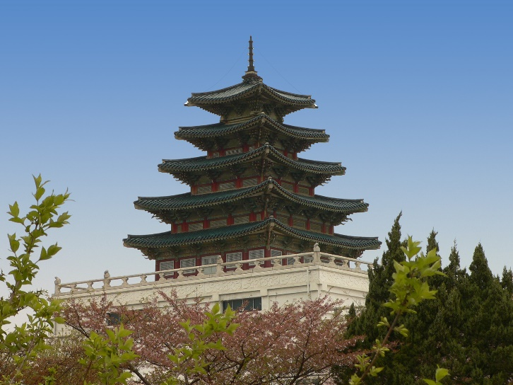With its blend of ancient traditions and cutting-edge modernity, Japan is undoubtedly one of the most intriguing places on earth. For a true immersion experience in Japanese traditions and hospitality, don’t miss the opportunity to spend at least one night in a *ryokan*, a traditional Japanese style inn, preferably one attached to a hot springs resort.

Japan has more active volcanoes than any other country in the world, with more than 10% of all the earth's volcanoes. All this volcanic activity has created more than 10,000 known thermal vents in the surface of the country, and of these, over 2,100 have been developed into hot-spring spas called *onsen*. Some onsen are public baths, which you can visit for a modest fee, and many onsen belong to a ryokan.

In a ryokan, guests stay in Japanese style rooms with a traditional *tatami* (straw matting used as a floor), furnished only with a low table. At night, futons are spread on the tatami for sleeping, but these are folded and stored in a closet during the day. In the better ryokans, Japanese-style breakfast and dinner, often featuring regional specialties, are included in the price and are served to guests in their room, usually by smiling women dressed in kimonos.

When you arrive at a ryokan, you remove your shoes at the entrance, and slip into a pair of slippers, given to you when you check-in. You wear the slippers whenever you walk around the ryokan, such as from your room to the bath and other common areas. You remove even these slippers before stepping onto the tatami in your room.

In addition, a *yukata*, a kimono-style cotton robe, is provided and is to be worn during your stay at the ryokan. You can wear your yukata for walking around the ryokan and as pajamas. In many onsen resorts, it is also okay to take a walk outside of the ryokan wearing your yukata; in fact, it’s rare to ever see guests wearing anything other than a yukata at an onsen resort. (Note, however, that unlike the yukata provided at ryokans, the yukata provided at Western style hotels are not to be worn outside your room!).

One of the best aspects of staying in a ryokan is the opportunity to enjoy a Japanese style bath, which is usually communal, with gender-separated areas for washing and soaking. In hot spring resorts, the ryokan's bath water is directly supplied from the hot spring, with different minerals reputed to have different health benefits. You begin a bath by rinsing quickly outside the bath and then sinking into the deep, hot—often very hot—bath water. After soaking for a while, you emerge from the bath to scrub and rinse your body while sitting on a small stool in front of a faucet, and then you slip back into the bath for a final soak. Japanese baths are enjoyed communally, but if you would prefer a private bath it can sometimes be arranged by reservation.

All QST Japan tours feature ryokan and onsen accommodations. For more information, visit QST on the Web at www.questspecialtytravel.com.

**Language and Culture Immersion: Antigua, Guatemala**

*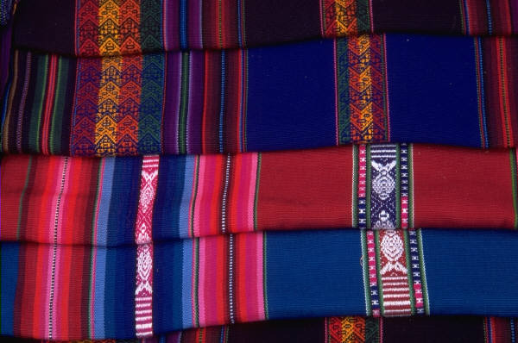*

Y

ou don’t need to schlep halfway around the world to experience a truly exotic country: magical, colorful, irresistible Guatemala is reachable from most North American cities by dinnertime. The cobblestone streets of the splendid Spanish colonial city of Antigua are made for walking, or, for a total-immersion experience, you can hop on a local “chicken bus” and practice your Spanish. Dazzling Guatemalan crafts and textiles are sold in boutiques, but the outdoor handicraft markets offer more fun, incredible photo opportunities, and better prices.

QST’s 12-day **Guatemala Arts and Culture Tour** is based in Antigua, where you spend mornings practicing Spanish one-on-one with a private tutor, and afternoons exploring Antigua and the surrounding villages. The tour includes overnight trips to a coffee plantation, the active volcano Pacaya, and the Mayan village San Antonio Aguas Calientes. Accommodations are with host families.

**Luxurious Adventure: Tunisia**

T

unis’s medina, or old city, founded in the seventh century, is a labyrinth of winding streets that pulse with life and excitement. The smells of fresh bread, spices, and honey-drenched pastries waft through the *souks*, markets where sparkling gold and silver items compete for attention with ceramics, leather, rugs, and mounds of fragrant spices, all while hordes of locals bustle amid the frequent calls to prayer from the Great Mosque. Beyond Tunis, colorful, friendly Tunisia beckons with pristine beaches, Roman ruins, the Sahara Desert, mosques, camel rides, Andalusian architecture, ancient souks, Star Wars film sets, oases, and some of the best haute cuisine in Northern Africa.

QST’s 10-day **Tunisia Adventure Tour** begins and ends in Tunis, with 7 days spent exploring desert cave dwellings, ancient Berber towns, key Roman ruins, and Tunisia’s Mediterranean coast. Travel is by air-conditioned four-wheel drive vehicles and accommodations are first-rate hotels.

**Birding and Cultural Heritage: Southern Bohemia**

W

hite-tailed and Imperial Eagle, Great Bustard, Eagle and Pygmy Owl, Hazel Grouse—you will see all these and more, amid the stunning backdrop of southern Bohemia. After birding in a variety of habitats, you relax in the small medieval towns along the southern border of the Czech Republic, where cobbled lanes lead to mystical castles, gothic cloisters, moors, meadows, streams, world heritage sites, and wine cellars humming with folk music.

QST’s 7-day **Birding the Czech Republic Tour** begins and ends in Prague. Accommodations are in small hotels and with host families.

**Featured Tour Details**

|  |  |  |  |
| --- | --- | --- | --- |
| Tour | Season | Length | Cost |
| Guatemala Arts and Culture | October-June | 12 days | $2,450 |
| Tunisia Adventure | April-October | 10 days | $4,950 |
| Birding the Czech Republic | April-October | 7 days | $3,270 |
| South Africa Safari | November-May | 10 days | $3,500 |
| Garden of South Africa | November-May | 8 days | $2,450 |

Traveler’s Corner

**Malaria: A Serious Health Risk for Travelers**

Each year an estimated eight million North Americans travel to countries where malaria is common. Transmitted by the bite of an infected mosquito, malaria is a serious and potentially fatal infectious disease that is characterized by headaches, fever, chills, and sweating. According to the Center for Disease Control, malaria can usually be prevented if travelers to tropical and subtropical regions follow these preventive steps:

First, inform yourself about the risk of acquiring malaria in the region of the world where you plan to travel. Malaria exists throughout the tropics, but it is most prevalent in sub-Saharan Africa. Malaria hotspots change constantly, so check with a travel medicine specialist or the Center for Disease Control for the latest developments before you travel.

Second, take measures to prevent mosquito bites, particularly between dusk and dawn. Always sleep in a well-screened room, preferably under a mosquito net that has been treated with insecticide. During the evening, wear long pants and long-sleeved shirts, and apply an insect repellent that contains DEET.

Finally, consult your physician or a travel medicine specialist several weeks prior to departure for advice on taking antimalarial drugs. Chemoprophylaxis drugs need to be taken continuously, beginning before travel commences through up to four weeks after leaving malaria-endemic areas.

Even if you take antimalarial pills, it is still possible to get malaria, so seek medical treatment promptly if you experience flu-like symptoms and are in or have recently visited an area where malaria is present. For more information on malaria prevention and other travel health issues, check out the Center for Disease Control on the Internet at www.cdc.gov/travel.

**Ten Tips for Traveling Abroad**

If you are traveling abroad, here are the State Department’s top ten tips for making your trip easier:

1. Make sure you have a signed, valid passport and visas, if required. Also, before you go, fill in the emergency information page of your passport.
2. Read the Consular Information Sheets (and Public Announcements or Travel Warnings, if applicable) for the countries you plan to visit.
3. Familiarize yourself with local laws and customs of the countries to which you are traveling. While in a foreign country, you are subject to its laws.
4. Make two copies of your passport identification page. Leave one copy at home with friends or relatives. Carry the other with you in a separate place from your passport.
5. Leave a copy of your itinerary with family or friends at home so that you can be contacted in case of an emergency.
6. Do not leave your luggage unattended in public areas. Do not accept packages from strangers.
7. Prior to your departure, register with the nearest embassy or consulate. Registration will make your presence as well as your whereabouts known in case it is necessary to contact you in an emergency.
8. To avoid being a target of crime, try not to wear conspicuous clothing and expensive jewelry and do not carry excessive amounts of money or unnecessary credit cards.
9. In order to avoid violating local laws, deal only with authorized agents when you exchange money or purchase art or antiques.
10. If you get into trouble, contact the nearest embassy.

*Source: U.S. Department of State.*

**Asia’s Airports Voted the Best by Passengers**

Asia's airports emerged as world favorites, according to a new survey. SkyWatch, a US-based aviation consultancy firm, surveyed 6.9 million airline passengers from 93 countries over a 12-month period. The top-rated airports were Hong Kong International Airport, Changi International Airport in Singapore, Schiphol Airport in Amsterdam, Seoul Incheon Airport, and Kuala Lumpur International Airport.